Sranbs/gNodeb Interface and RB report for IPv6

Case-1:
We have Adjnode and association values for a node where local IP are IPv6 and remote IPs are IPv4 under addinfo report
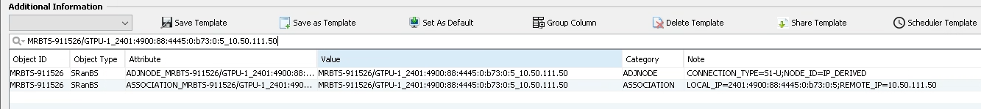

In IPDATA local IP are available in IPV6 tab, and remote IP are available in IPv4 tab
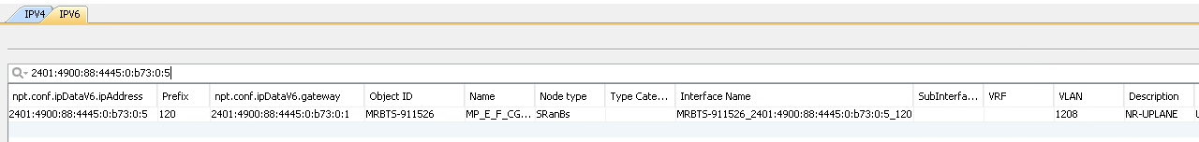
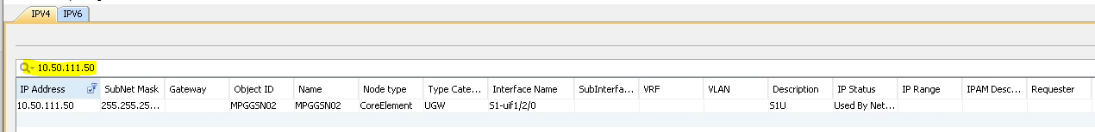
However, interface report does not have interface for it
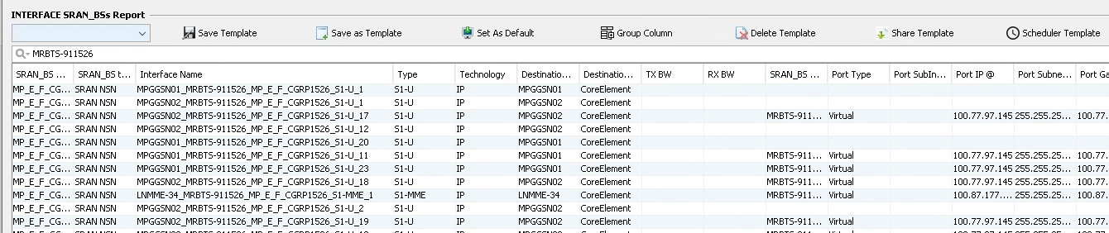

Case-2:
We have Adjnode and association values for a node where both local and remote IPs are IPv6 under addinfo report
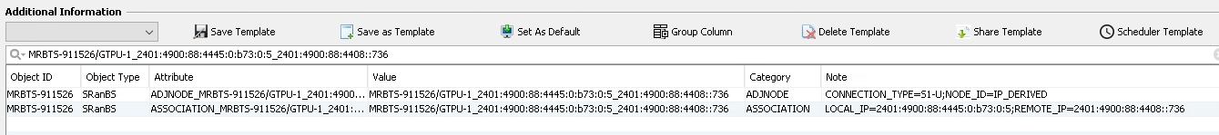

In IPDATA local IP are available in IPV6 tab
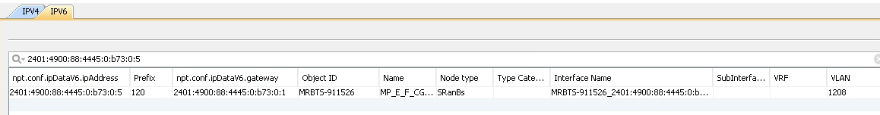

Interface are not available in sranbs report

Case-3:
We have Adjnode and association values for a node where local IP are IPv4 and remote IPs are IPv6 under addinfo report

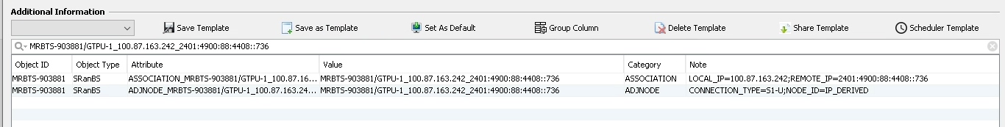
In IPDATA local IP are available in IPV4 tab

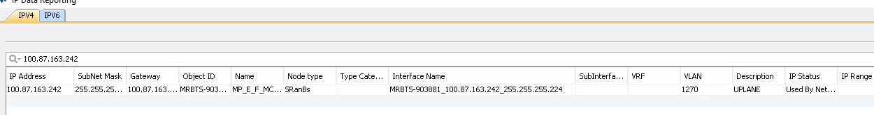
In IPDATA Remote IP are not available in IPV6 tab
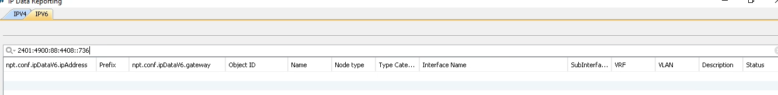

Interface are not available in sranbs report

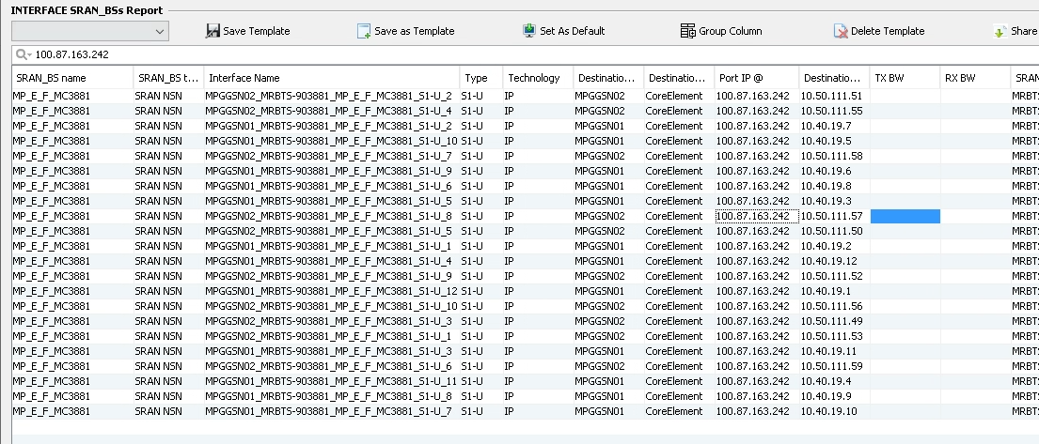

Case 4:
For gNodeb type, we have Adjnode and association values for a node where local IP are IPv6 and remote IPs are IPv6 under addinfo report

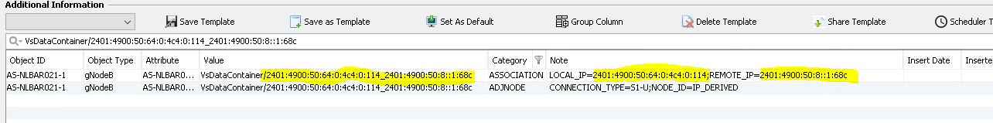

In IPDATA local IP are available in IPV6 tab

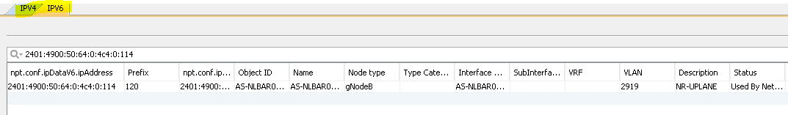
In IPDATA Remote IP are available in IPV6 tab

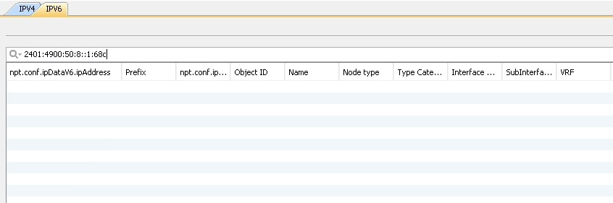

Interface are not available in sranbs report

